

AP® Physics C
1997 Free response Questions

The materials included in these files are intended for use by AP teachers for course and exam preparation in the classroom; permission for any other use must be sought from the Advanced Placement Program®. Teachers may reproduce them, in whole or in part, in limited quantities, for face-to-face teaching purposes but may not mass distribute the materials, electronically or otherwise. These materials and any copies made of them may not be resold, and the copyright notices must be retained as they appear here. This permission does not apply to any third-party copyrights contained herein.

These materials were produced by Educational Testing Service® (ETS®), which develops and administers the examinations of the Advanced Placement
Program for the College Board. The College Board and Educational Testing Service (ETS) are dedicated to the principle of equal opportunity, and their
programs, services, and employment policies are guided by that principle.

The College Board is a national nonprofit membership association dedicated to preparing, inspiring, and connecting students to college and opportunity.
Founded in 1900, the association is composed of more than 4,200 schools, colleges, universities, and other educational organizations. Each year, the
College Board serves over three million students and their parents, 22,000 high schools, and 3,500 colleges, through major programs and services in
college admission, guidance, assessment, financial aid, enrollment, and teaching and learning. Among its best-known programs are the SAT®, the
PSAT/NMSQT®, and the Advanced Placement Program® (AP®). The College Board is committed to the principles of equity and
excellence, and that commitment is embodied in all of its programs, services, activities, and concerns.

APIEL is a trademark owned by the College Entrance Examination Board. PSAT/NMSQT is a registered trademark jointly owned by the College Entrance Examination Board and the National Merit Scholarship Corporation. Educational Testing Service and ETS are registered trademarks of Educational Testing Service.
1997M1. A nonlinear spring is compressed horizontally. The spring exerts a force that obeys the equation F(x) = Ax^{½}, where x is the distance from equilibrium that the spring is compressed and A is a constant. A physics student records data on the force exerted by the spring as it is compressed and plots the two graphs below, which include the data and the student's best-fit curves.
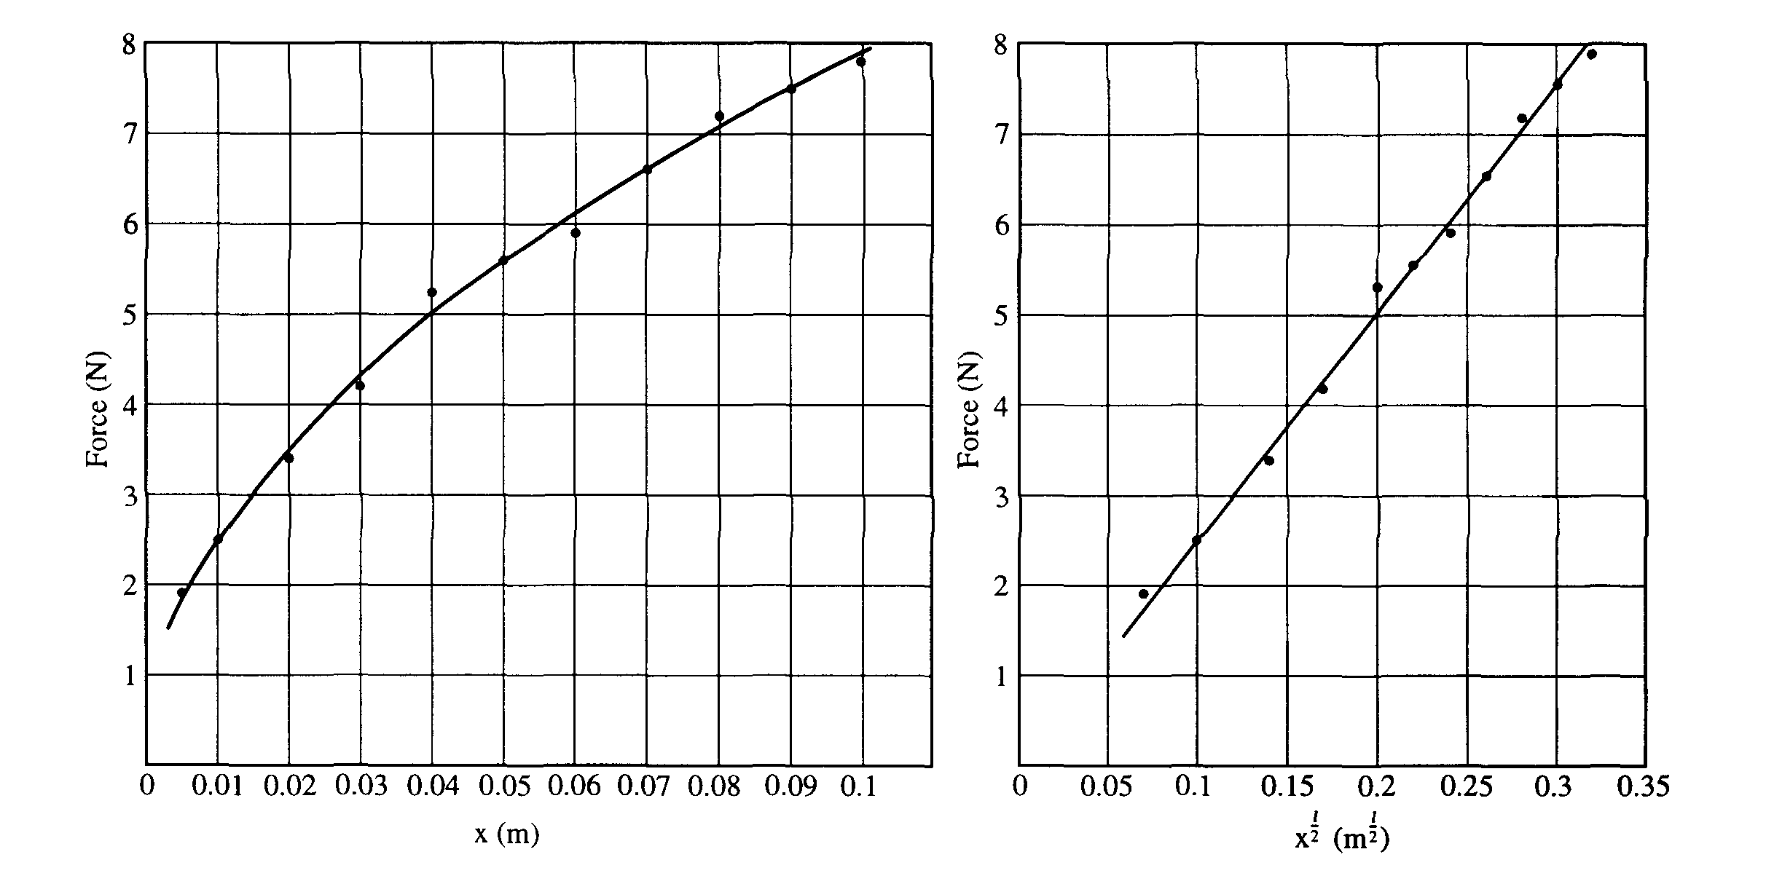
a. From one or both of the given graphs, determine A. Be sure to show your work and specify the units.
b. i. Determine an expression for the work done in compressing the spring a distance x.
ii. Explain in a few sentences how you could use one or both of the graphs to estimate a numerical answer to part (b)i for a given value of x.
c. The spring is mounted horizontally on a countertop that is 1.3 m high so that its equilibrium position is just at the edge of the countertop. The spring is compressed so that it stores 0.2 J of energy and is then used to launch a ball of mass 0.10 kg horizontally from the countertop. Neglecting friction, determine the horizontal distance d from the edge of the countertop to the point where the hall strikes the floor

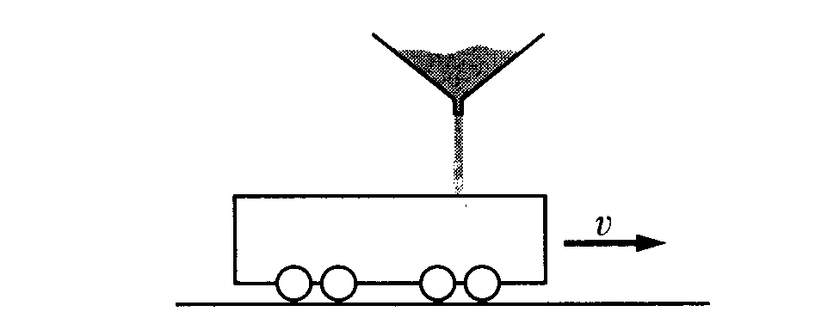

1997M2. An open-top railroad car (initially empty and of mass M_{o}) rolls with negligible friction along a straight horizontal track and passes under the spout of a sand conveyor. When the car is under the conveyor, sand is dispensed from the conveyor in a narrow stream at a steady rate ΔM/Δt = C and falls vertically from an average height h above the floor of the railroad car. The car has initial speed v_{o} and sand is filling it from time t = 0 to t = T. Express your answers to the following in terms of the given quantities and g.
a. Determine the mass M of the car plus the sand that it catches as a function of time t for C < t < T.
b. Determine the speed v of the car as a function of time t for 0 < t < T.
c. i. Determine the initial kinetic energy K_{i} of the empty car.
ii. Determine the final kinetic energy K_{f} of the car and its load.
iii. Is kinetic energy conserved? Explain why or why not.
d. Determine expressions for the normal force exerted on the car by the tracks at the following times.
i. Before t = 0
ii. For 0 < t < T
iii. After t = T

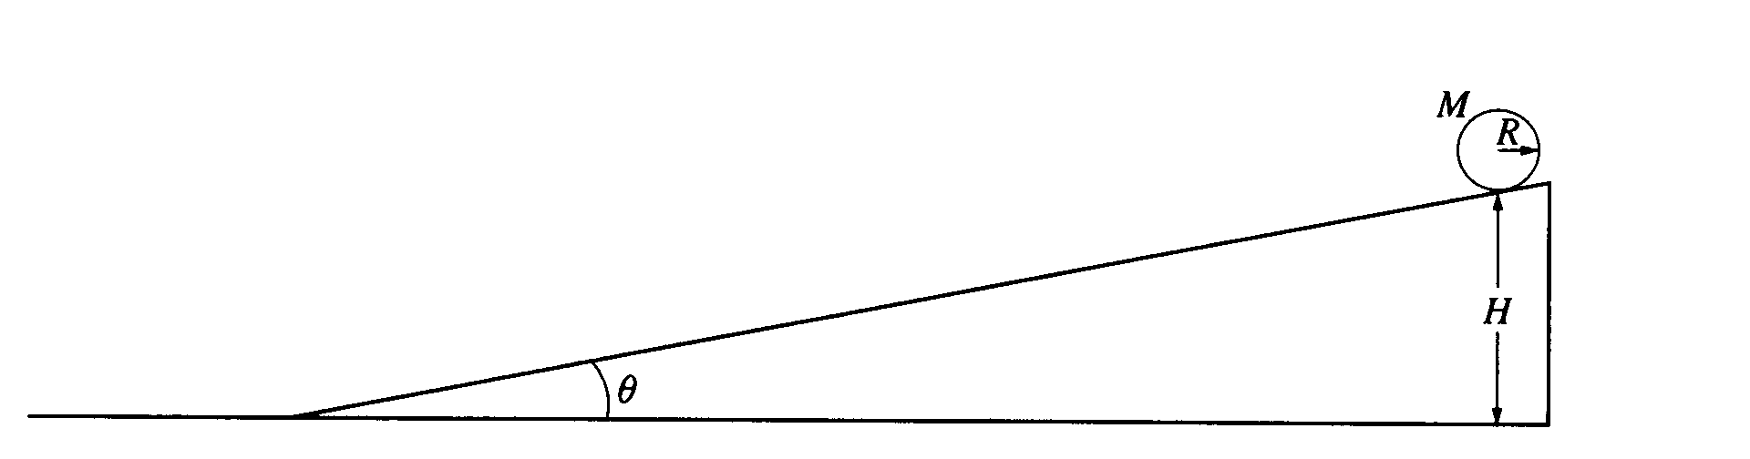

1997M3. A solid cylinder with mass M, radius R, and rotational inertia ½MR² rolls without slipping down the inclined plane shown above. The cylinder starts from rest at a height H. The inclined plane makes an angle θ with the horizontal. Express all solutions in terms of M, R, H, θ, and g.
a. Determine the translational speed of the cylinder when it reaches the bottom of the inclined plane.
b. On the figure below, draw and label the forces acting on the cylinder as it rolls down the inclined plane Your arrow should begin at the point of application of each force.
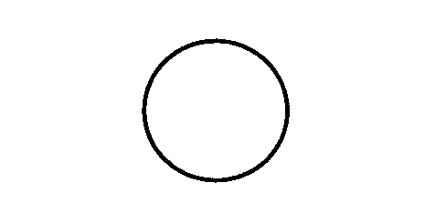

c. Show that the acceleration of the center of mass of the cylinder while it is rolling down the inclined plane is (2/3)g sinθ.
d. Determine the minimum coefficient of friction between the cylinder and the inclined plane that is required for the cylinder to roll without slipping.
e. The coefficient of friction μ is now made less than the value determined in part (d), so that the cylinder both rotates and slips.
i. Indicate whether the translational speed of the cylinder at the bottom of the inclined plane is greater
than, less than, or equal to the translational speed calculated in part (a). Justify your answer.
ii. Indicate whether the total kinetic energy of the cylinder at the bottom of the inclined plane is
greater than, less than, or equal to the total kinetic energy for the previous case of rolling without
slipping. Justify your answer.

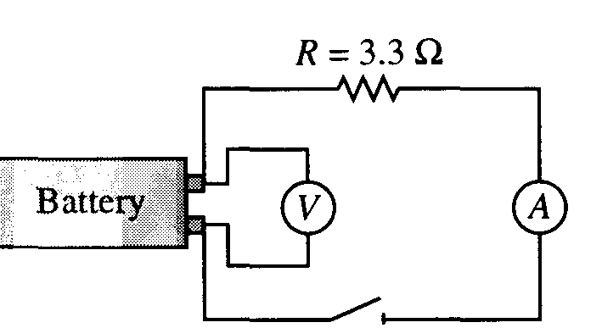
1997E1. A technician uses the circuit shown above to test prototypes of a new battery design. The switch is closed, and the technician records the current for a period of time. The curve that best fits the results is shown in the graph below.
The equation for this curve is I = I_{o}e^{-kt} where t is the time elapsed from the instant the switch is closed and I_{o} and k are constants.
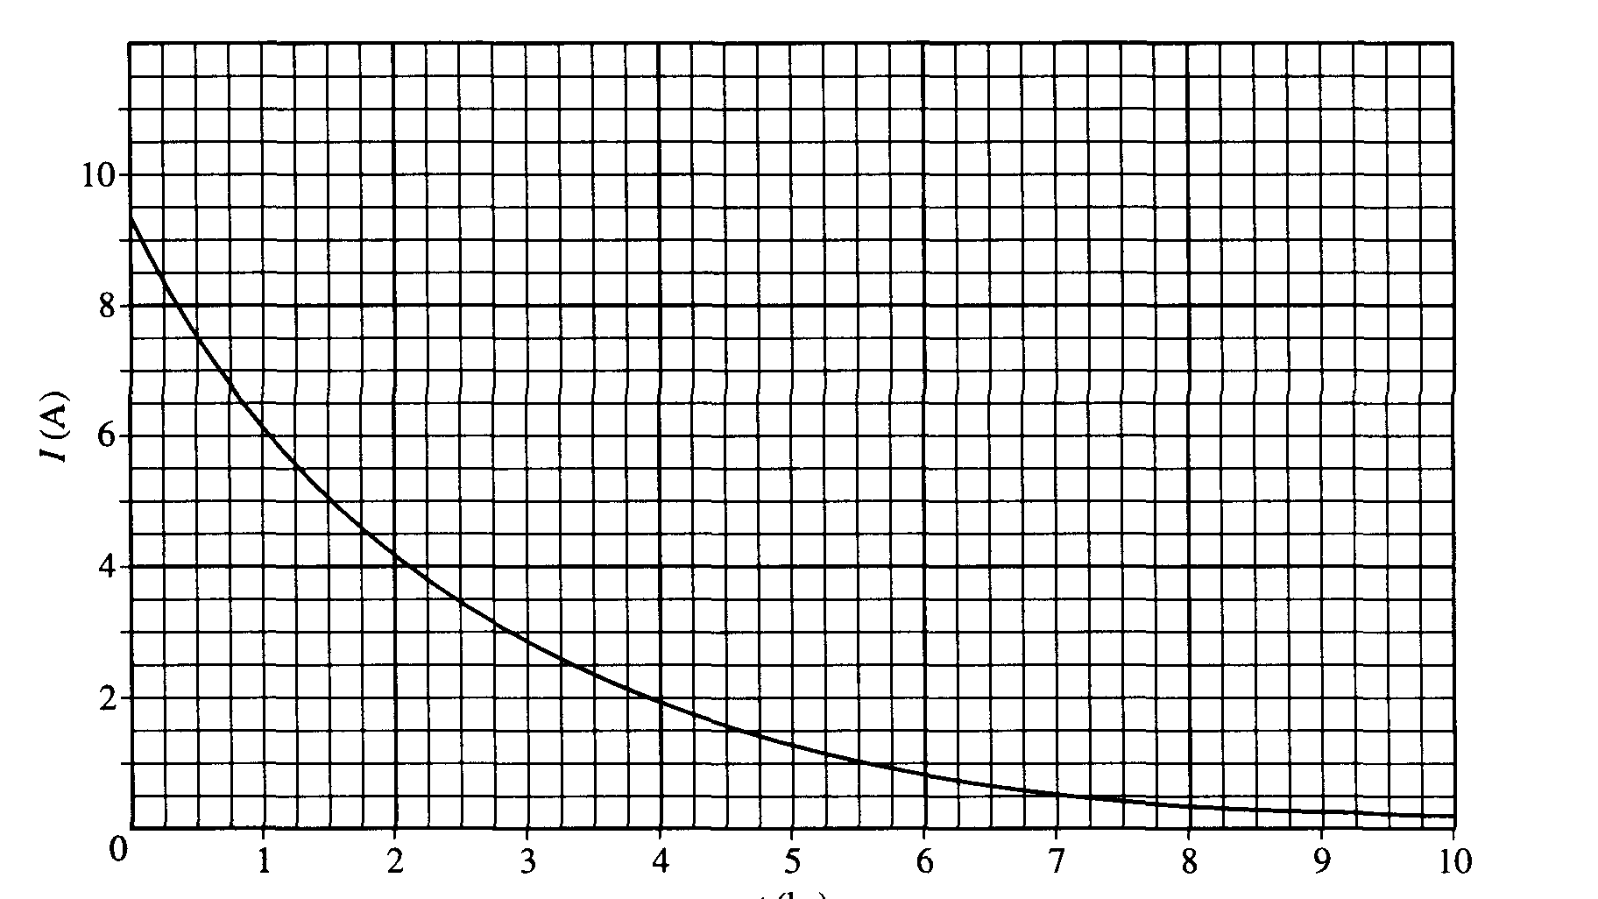
t (hr)

a. i. Using the information in the graph, determine the potential difference V_{o} across the resistor immediately after the switch is closed.
ii. Would the open circuit voltage of the fresh battery have been less than, greater than, or equal to the value in part i ? Justify your answer.
b. Determine the value of k from this best-fit curve. Show your work and be sure to include units in your answer.
c. Determine the following in terms of R, I_{o}, k, and t.
i. The power delivered to the resistor at time t = 0
ii. The power delivered to the resistor as a function of time t
iii. The total energy delivered to the resistor from t = 0 until the current is reduced to zero

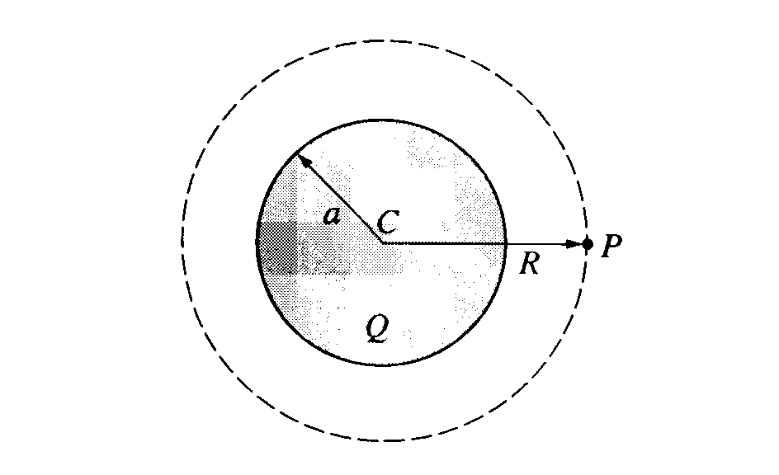
1997E2. A nonconducting sphere with center C and radius a has a spherically symmetric electric charge density. The total charge of the object is Q > 0.
a. Determine the magnitude and direction of the electric field at point P, which is a distance R > a to the right of the sphere's center.
b. Determine the flux of the electric field through the spherical surface centered at C and passing through P.
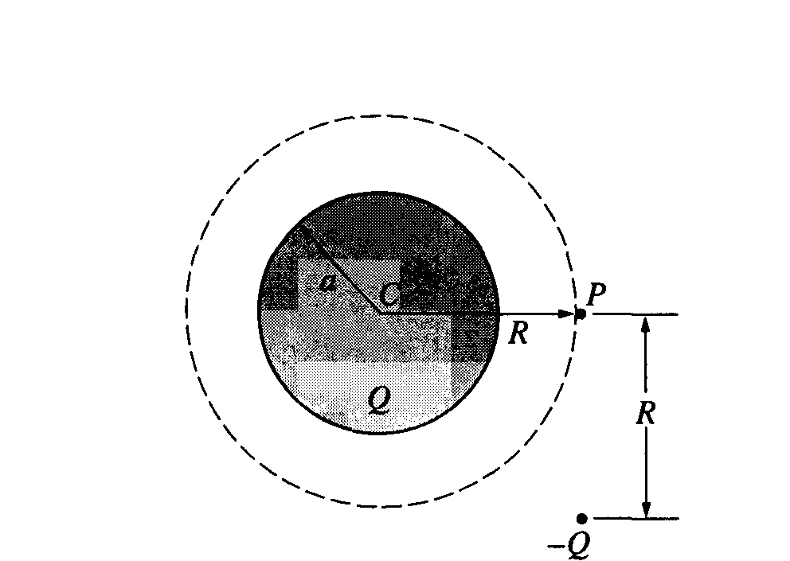

A point particle of charge -Q is now placed a distance R below point P. as shown above.
c. Determine the magnitude and direction of the electric field at point P.

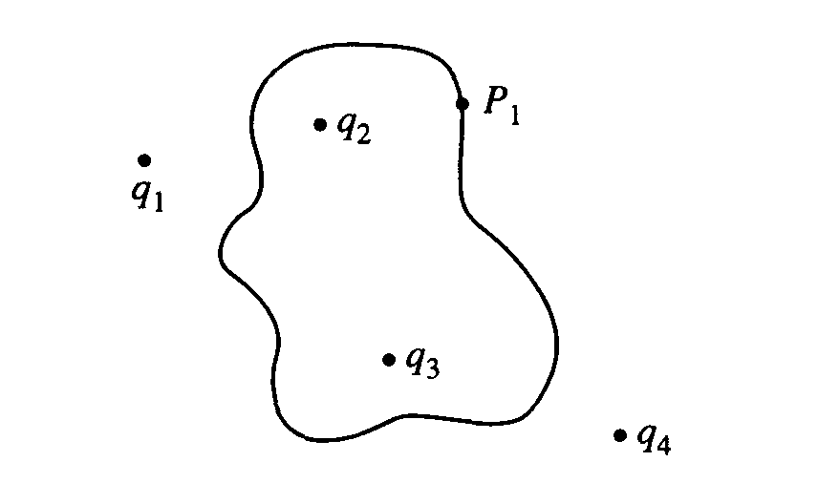
d. Now consider four point charges, q₁, q₂, q₃, and q₄, that lie in the plane of the page as shown in the diagram above. Imagine a three-dimensional closed surface whose cross section in the plane of the page is indicated.
i. Which of these charges contribute to the net electric flux through the surface?
ii. Which of these charges contribute to the electric field at point P₁ ?
iii. Are your answers to i and ii the same or are they different? Explain why this is so.
e. If the net charge enclosed by a surface is zero, does this mean that the field is zero at all points on the surface? Justify your answer.
f. If the field is zero at all points on a surface, does this mean there is no net charge enclosed by the surface? Justify your answer.

1997E3. A long, straight wire lies on a table and carries a constant current I₀, as shown above.

a. Using Ampere's law, derive an expression for the magnitude B of the magnetic field at a perpendicular distance r from the wire.

A rectangular loop of wire of length l, width w, and resistance R is placed on the table a distance s from the wire, as shown below.
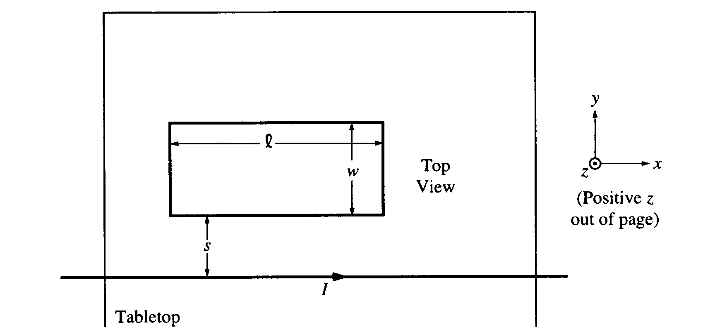
b. What is the direction of the magnetic field passing through the rectangular loop relative to the
coordinate axes shown above on the right?
c. Show that the total magnetic flux φ_{m} through the rectangular loop is 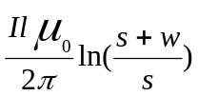
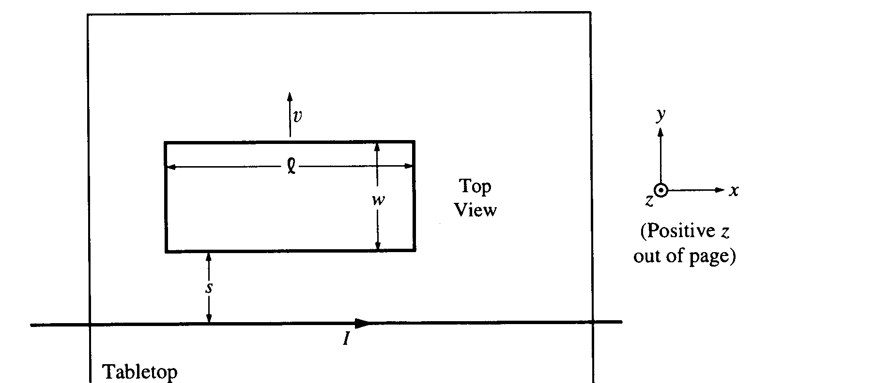

The rectangular loop is now moved along the tabletop directly away from the wire at a constant
speed v = |ds/dt⏐as shown above.
d. What is the direction of the current induced in the loop? Briefly explain your reasoning.
e. What is the direction of the net magnetic force exerted by the wire on the moving loop relative to the coordinate axes shown above on the right? Briefly explain your reasoning.
f. Determine the current induced in the loop. Express your answer in terms of the given quantities and fundamental constants.

